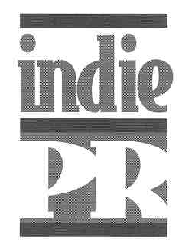

LAUGHING MATTERS
...The Men

Directed by Andrea Meyerson

Featuring:

Bruce Vilanch
Alec Mapa
Bob Smith
Andre Kelley
Scott Kennedy
Eddie Sarfaty

Press contact: Jim Dobson / Indie PR (323) 964-0700 starpr@aol.com

Synopsis…..

Laughing Matters...The Men features outstanding gay comics and in partnership with

Logo, will air on the Logo Television Network in Fall 2007. The third installment in her

series on queer comics, Andrea Meyerson, whose “Laughing Matters” and “Laughing

Matters…More!” won audience awards in festivals worldwide, now brings the boys to

the forefront in this hilarious offering. Shot in her winning formula that interweaves stand-

up material with candid interviews, viewers are given the opportunity to at once laugh and

simultaneously understand the voyage that has led these performers to the stage...and

what performers! Meet sexy Kansan Andre Kelley, who boasts being the only black comic

never to have appeared on B.E.T.; Scott Kennedy, whose three years in military school

and youth in rural Texas makes for hilarious anecdotes; Alec Mapa who went from growing

up in a conservative Filipino Catholic family to being the first openly gay Asian regular on a

television series; Bob Smith, who was the first-ever out gay comic to appear on "The

Tonight Show" and to have his own HBO comedy special, and Bruce Vilanch, who all of

Hollywood calls when they need fresh and funny material.

FROM THE DIRECTOR…

The Concept…

My first film, Laughing Matters, was created in 2002 and was inspired after nearly 10 years

of producing comedy shows and concerts geared toward the lesbian community. I

wanted to pay tribute to the pioneers of lesbian comedy. Then, Ellen and Rosie came out.

As mainstream celebrities, their coming out was powerful and helped change the way TV

and film relates to and portrays the LGBT community. But I couldn’t help but feel

sensitivity to the performers who had been out from the beginning of their careers. Ellen

and Rosie are extraordinary entertainers but would they have reached their level of
celebrity if they were open about their sexuality from the beginning? And would these

talented, brilliant “out” performers have been mainstream celebrities if they had stayed in

the closet during the early years of their career? How could we overlook the performers

that had been out for 20 to 25 years?

Both paths are important roads and deserve to be commended and celebrated. While

Ellen and Rosie were constantly being acknowledged and honored for coming out, I

thought it was time for the women who took the other path, the women who were open

and honest about themselves from the beginning of their careers, to be given the same

accolades for their courage, integrity and talent. And that’s how Laughing Matters was

born.

Two years later, equipped with a better understanding of filmmaking and an overwhelming

desire to make more movies, I cast four more talented lesbian comics and made Laughing

Matters…More! The first film featured the “pioneers” and this film showcased the women

who were able to walk down the path that the pioneers paved for them.

During production on Laughing Matters…More! I knew I wanted to create a similar film for

gay comics and that that would be my next film. It’s less familiar territory for me but I knew

of so many funny out gay performers. I had to showcase their talent and tell their stories as

well, hence Laughing Matters…The Men was made.

The Casting…

My first thought was not to be tied to featuring four comics, as I did in the first two films. It

was more about casting talented gay men who have unique styles and stories. I felt the

film about the men should have a completely different vibe and casting these six

extraordinary performers really helped create that. They’re comics, writers and actors and

whether they’re onstage or off, they’re funny, poignant and brilliant!

Bob Smith is the “Kate Clinton” on the gay men’s comedy circuit. I consider him a

trailblazer. He was not only the first out gay comic to perform comedy onstage to a

straight audience, have his own HBO special and appear on The Tonight Show,

but he has mentored many gay comics throughout the years.

I had worked with Andre Kelley before so I knew how talented he was and how much the

audience loved him. His humor is biting and it has clearly developed from his own personal

experiences, but his charm and delivery captivates everybody. He has an interesting

career path and shares that in the film. He’s also adorable!

Bruce Vilanch was a no-brainer! I had to have him in this film! His humor and stage

presence is like no one else out there. He doesn’t really do a lot of standup because he’s

busy writing comedy for everyone else in Hollywood. He is loved by the LGBT community

and with good reason. He has done so much to support our civil rights, AIDS and just

about every cause out there. He is an icon and his story was important to share.

Alec Mapa is an amazing comedian and actor and there is no one else like him around! It

doesn’t take long to figure out he has been on Broadway. His theatrical training is really

portrayed in his comedy act. His material is fresh and unique. And he shares an interesting

perspective of growing up in San Francisco with a Catholic Filipino upbringing.

I have seen Scott Kennedy perform many times and knew that he would play an important

role in the film. He breaks all stereotypes of what a gay man is! He embraces that onstage

and off.

Eddie Sarfaty is a bit newer on the gay comedy circuit and that brings an interesting

perspective to the storyline of the film. His brand of comedy is very gay, Jewish and

hysterical! He has also worked with Bob Smith through the years and that ties in nicely.

-MORE-

The Final Selection…

In choosing the men to feature, I was inspired by how talented these comics are--their

material, their pacing and delivery. I was also looking for diversity; I wanted the cast

to represent as many types of people as possible--culturally as well as comically.

The Filming…

Palm Springs Pride, what better setting for profiling six out gay performers? I’d been to

Palm Springs Pride weekend the two years prior to the shoot and I loved the energy.

It has become a gay Mecca and the Pride celebration just accentuates that. Palm Springs

has a small-town feel yet its Pride is a citywide event--almost everyone in town is

involved, gay or not. It’s California, it’s sunny and it’s gay, gay, gay!

This was my first time working so closely with gay men and I loved it! I felt nothing but

gratitude from them. Everyone bonded and respected one another. I felt honored that they

let me tell their stories–a lesbian no less!

The Inspiration…

I love that this film tells the individual stories of six accomplished performers and at the

same time reveals common threads within the gay community. It’s very real, moving and

funny. I think audiences will walk away with sore cheeks from laughing so much but I also

think they’ll be deeply touched. There are two things that I strive to achieve in all my films

in the Laughing Matters series: to “entertain” and to “enlighten.”

Andrea Meyerson / 2007

-MORE-

About the Filmmakers….

ANDREA MEYERSON (Executive Producer / Director)

Andrea Meyerson is a filmmaker and event producer whose concerts and comedy shows adorn some of Los Angeles’ most elite stages and whose films have aired on here! TV and MTV’s Logo network and screened at film festivals around the world.

Andrea founded All Out Films in 2002, producing and directing the award-winning Laughing Matters (2003) and Laughing Matters...More! (2006), showcasing the talents and personalities of outstanding lesbian comedians. Her most recent films include Laughing Matters...The Men (2007) and Kate Clinton: 25th Anniversary Tour (2007), both set to air on MTV’s Logo network.
Through StandOut Productions Inc., a company she founded in 1996, Andrea produces concerts and live comedy shows featuring some of the country’s best-known entertainers, including Joan Armatrading, Roseanne Barr, Nell Carter, Kate Clinton, Sophie B. Hawkins, Janis Ian, Holly Near, Vicki Randle, Toshi Reagan, Suzanne Westenhoefer and Cris Williamson. By combining the efforts of her two companies, she’s begun creating original content for the Logo network, such L.A. Women's Fest, an all-day comedy and music festival, and Suzanne Westenhoefer: Live from the Ladies Room, scheduled to air later this year.
Andrea is also a pioneer in the lesbian community, having started Women On A Roll in 1995, one of the largest grassroots lesbian social and cultural organizations in the country. She has been recognized as one of the Ten Amazing Women in Showbiz by PowerUp, a prestigious organization that promotes the visibility of gay women in entertainment; and honored by the Los Angeles Gay & Lesbian Center with the L.A.C.E. Award (Lesbians Active in Community Empowerment), for making significant contributions to the gay and lesbian community. In 2006, Andrea was among those selected to receive the WIN Outstanding Women Award from the Women's Image Network (WIN) and was one of four finalists for PlanetOut's Entrepreneur of the Year. This year she will be the first out lesbian to receive the Women of Achievement Award, presented by the YWCA for empowering women and eliminating racism

Sandra Chandler (Director of Photography)
Sandra Chandler is a graduate of the USC school of Cinema & Television. She has been shooting film and video for 20 years. In addition to Laughing Matters…More!, her credits include, HBO’s All Aboard! Rosie’s Family Cruise, The Eyes of Tammy Faye, The Young and the Dead, 101 Rent Boys for Cinemax; and currently on PBS The New Los Angeles. Sandra occasionally teaches documentary camera at USC.

Jen Bradwell (Editor)

Jen Bradwell is a San Francisco Bay Area-based editor. Since graduating from the University of Southern California’s film school, she has edited on several feature and television documentaries and has worked with award-winning filmmakers including Dyanna Taylor, Roberta Grossman, Ayoka Chenzira, Sally Heckel and Mark Reese.

Laurie Schenden (Interviewer)
The veteran Los Angeles journalist worked for many years as a columnist, news editor and entertainment writer for the Los Angeles Times. She conducted the interviews in the first two Laughing Matters films, and teamed with Andrea to create the storyline for the first film. Laurie also worked as a writer-story consultant on the award-winning documentary Christa MacAuliff: Reach for the Stars, which aired on CNN. She received her BA from Michigan State University and studied screenwriting at UCLA. She is currently filming oral histories of famous lesbians for a documentary film.

-MORE-

ABOUT THE MEN….

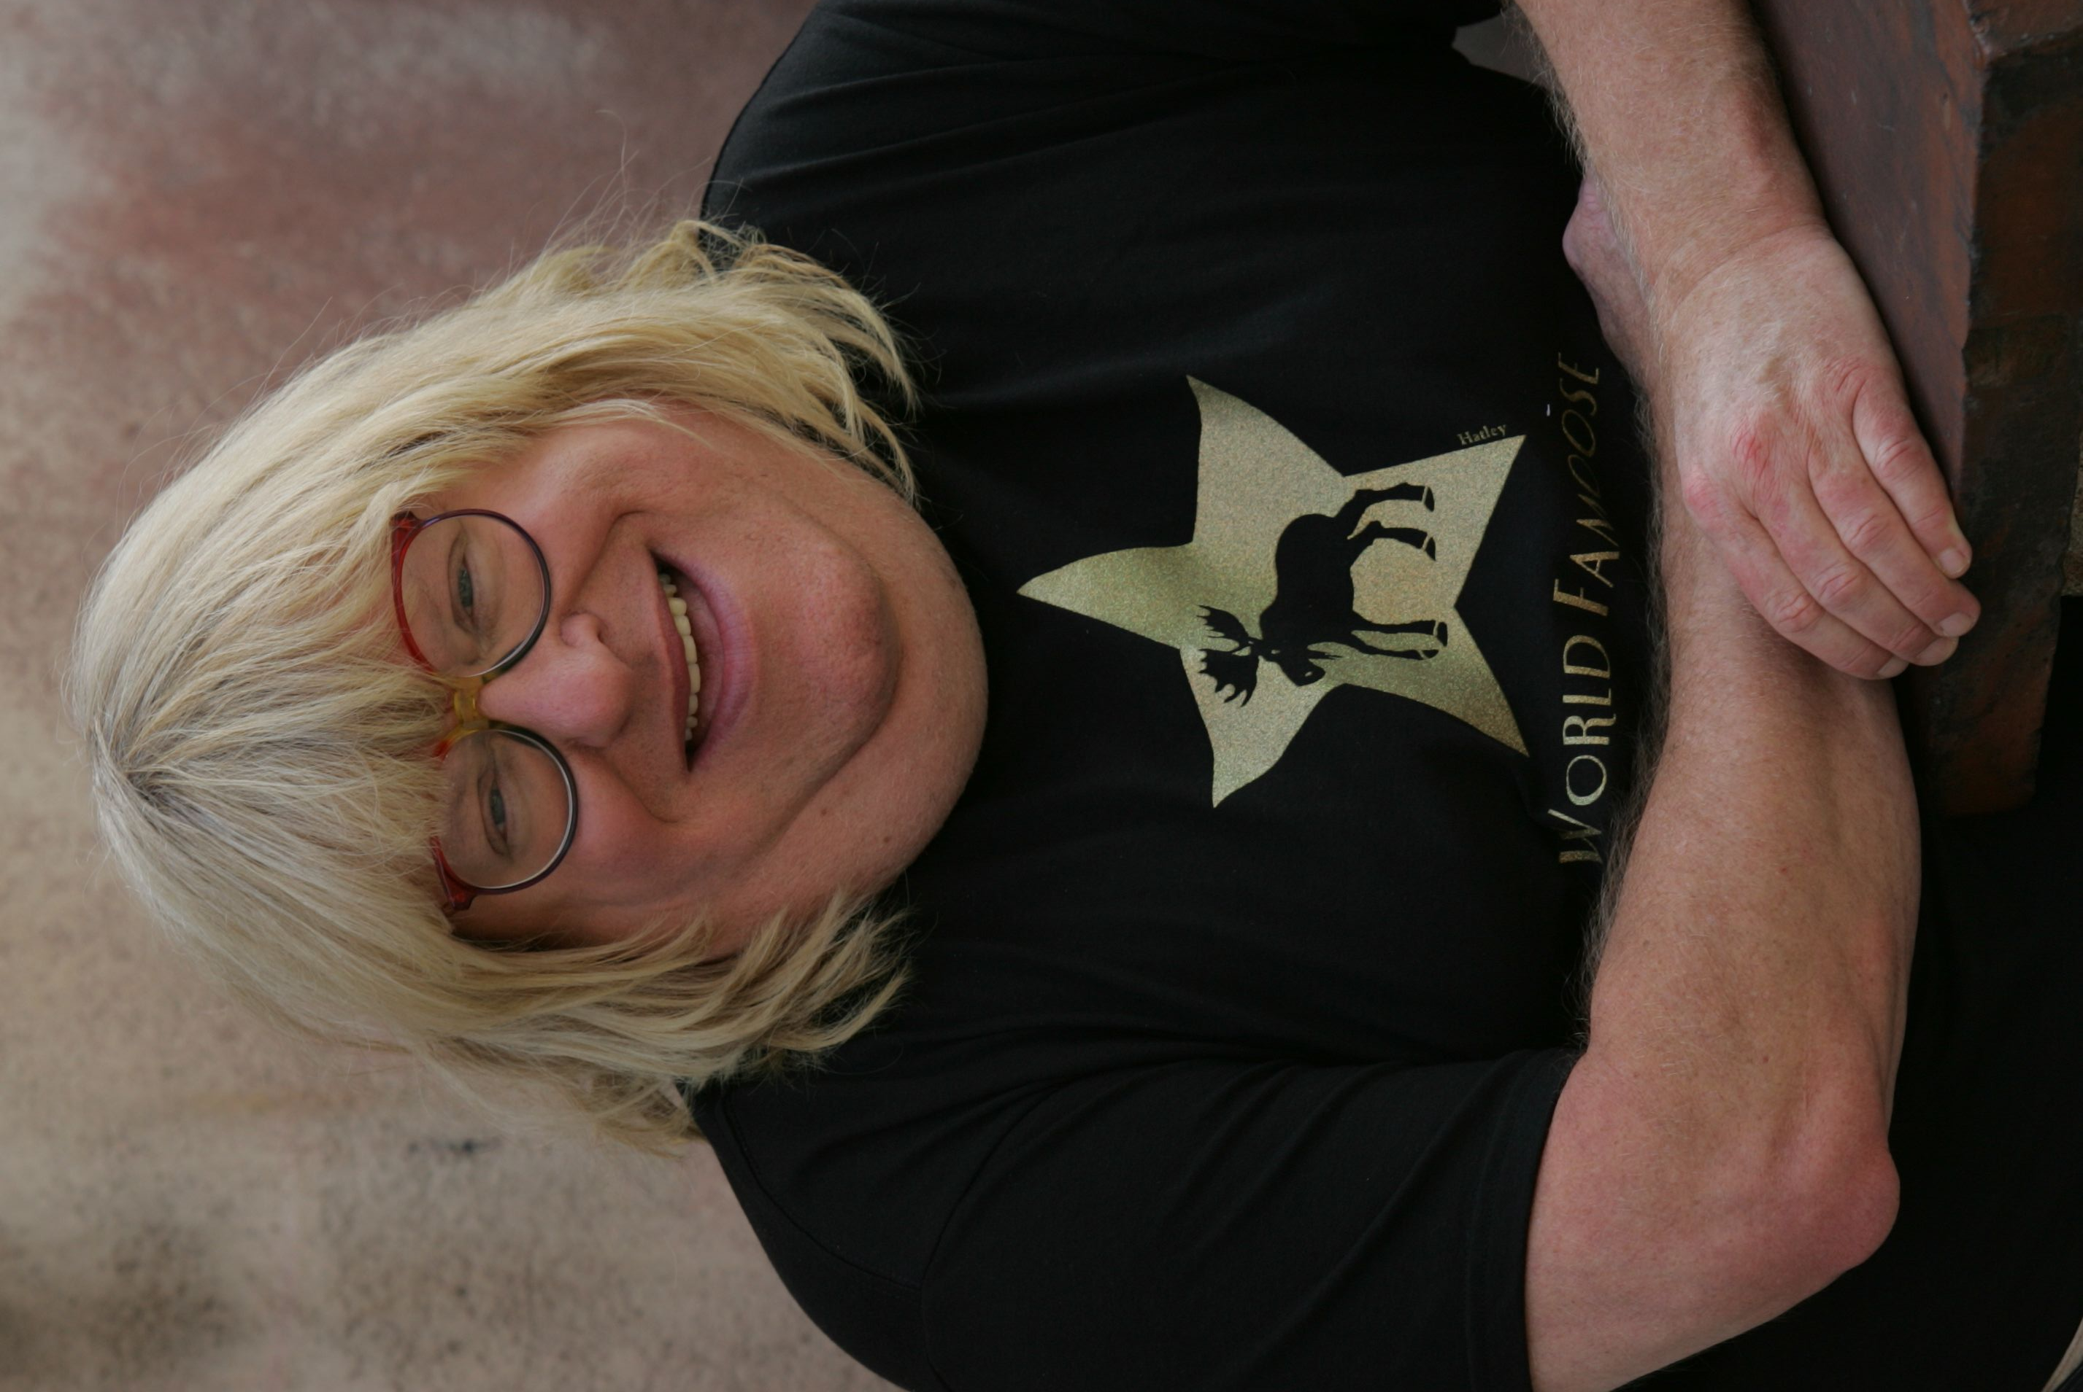

BRUCE VILANCH

Bruce Vilanch is a two-faced fella: Bearded, he is one of the most sought-after comedy writers in Hollywood, winner of a bunch of Emmys and noted as the “Hollywood Square” just to the left of Whoopi. Shaved, he spent two years as Edna Turnblad, Baltimore housewife and superstar, on tour and on Broadway in the smash musical adaptation of the John Waters film “Hairspray.”

Most recently in 2006, Bruce was seen on VH1’s popular fitness and nutrition reality-series, “Celebrity Fit Club,” which just finished its third season. Participating in a type of extreme-makeover-body-edition, the Celebrity Fit Clubbers went through 100 days of Fit Club training. Along the way, they learned about fitness, diets and nutrition.

Who knows what Bruce will look like for his next performance? In addition to “Hairspray,” he has appeared in such legendary epics as “Ice Pirates,” “Mahogany” and “The Morning After.” A frequent guest on talk shows, Bruce won his Emmys for co-writing back-to-back Oscar shows with Billy Crystal. He’s written 16 Oscar-casts so far, as well as a number of Tony, Grammy, and even Emmy shows, although he never got an Emmy for writing an Emmy–that would be award-show incest of the lowest order. His bizarre career was documented in the film “Get Bruce!,” released by Miramax and perpetually available on Buena Vista Home Video.

Bruce’s one-man show, “Almost Famous,” tickled Off-Broadway audiences for three months and has made a number of appearances around the country. He is frequently mistaken for Brad Pitt.

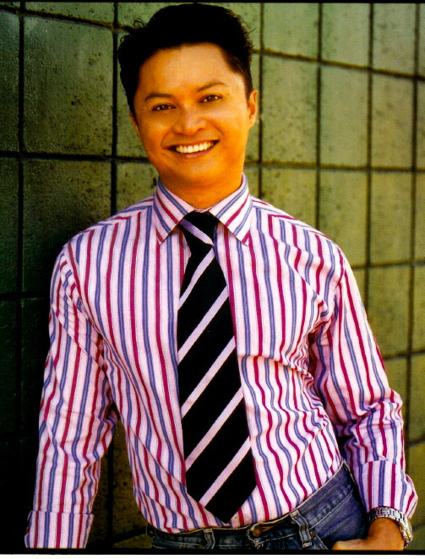

ALEC MAPA

Alec Mapa is a GLAAD award-winning actor, activist, playwright and journalist. He can currently be seen on the ABC show Desperate Housewives, where he recurs as Eva Longoria's best gay pal "Vern." Alec recently completed four seasons on the UPN comedy Half and Half. Moviegoers know Alec from the cult favorite Connie and Carla, where he starred opposite Toni Collette and Nia Vardalos as the loveable drag queen "N' Cream." Alec had the distinction of playing network television's very first gay Asian series regular character on the CBS sitcom Some of My Best Friends. His Wisecrack! comedy special on the gay MTV network LOGO premiered in 2005 and has been a network favorite, playing in heavy rotation ever since.

For promoting visibility on behalf of gay causes and issues, Alec received the GLAAD award in 2005. Alec's career began on Broadway where he starred in the Tony Award winning play M. Butterfly. He played the role of "Song Liling," Chinese transvestite spy, opposite Tony Randall for nearly a year before starring in the National Touring Company production. Other Broadway credits include Timon of Athens and A Little Hotel on the Side, both with the National Actor’s Theater. Off Broadway Alec appeared in the New York Shakespeare Festival/ Public Theater productions of Jessica Hagedorn's Dogeaters, directed by Michael Greif, and Chay Yew's A Language of Their Own. Theatergoers in LA have enjoyed the Mark Taper Forum productions of three of Alec’s solo shows; I Remember Mapa, Drama! and Mapa Mia! I Remember Mapa won the LA Weekly award for Best Solo Performance and has since played to sold out houses in Seattle, New York, Toronto and San Francisco.
As an activist, Alec has worked tirelessly performing on behalf of the Human Rights Campaign, the Los Angeles Gay and Lesbian Center, Broadway Cares/Equity Fights Aids, AIDS Project Los Angeles, Asian Pacific Aids Intervention Team, Gay and Lesbian Adolescent Social Services (GLASS), Lambda Legal, and the Matthew Shepard Foundation. For his community service, Alec received the award for continued excellence from the National Gay and Lesbian Task Force, and the Rand Schrader award for Distinguished Achievement from the Los Angeles Gay and Lesbian Center. Alec's column "Minority Retort" appears monthly in The Advocate, the national gay and lesbian news magazine. Alec is married to his partner of five years Jamison Hebert.

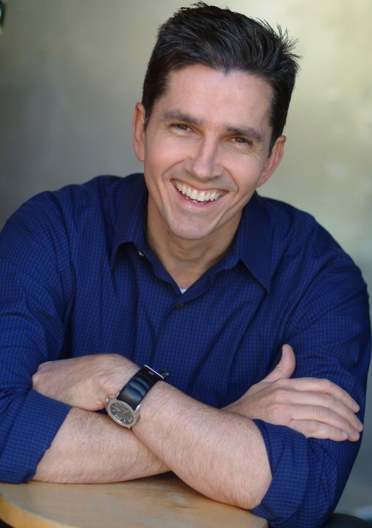

BOB SMITH

Born in Buffalo, Bob Smith has the distinction of being the first openly gay comedian to appear on The Tonight Show and also have his own HBO Comedy Half-hour. Other TV appearances include Politically Incorrect, The Late, Late Show, Entertainment Tonight, Tom Snyder and Comedy Central's Out There.

Bob's Lambda Literary Award-winning collection of essays, Openly Bob, was published to acclaim by Rob Weisbach Books/William Morrow and his most recent Lambda Literary Award-nominated book, Way to Go Smith!, was published by Rob Weisbach Books/HarperCollins.

He's written for Amblin Films, The MTV Video Awards, Dennis Miller, Roseanne and was a staff writer for Fox's MAD-TV. His sketch, The Zapruder Films was recently featured in The Best of MAD-TV. Bob's comic essays have appeared in 101 Damnations published by St. Martin's Press and the anthology America’s Best Contemporary Humorists: Mirth of a Nation. His most recent essay, "The Test," appears in When I Knew edited by Robert Trachtenberg for Harper Collins. Bob is a regular contributor to Out magazine, where he writes feature articles and the popular monthly list column. He recently appeared in HBO's documentary about the first gay and lesbian family cruise, All Aboard -- Rosie's Family Cruise.

In 2007, Bob will perform standup on Logo’s series Wisecracks. Bob is also extremely proud to announce that his first novel, Selfish and Perverse, will be published by Carroll & Graf in Sept 2007. His comedy about a gay man who goes to Alaska is already garnering praise from some of America’s best comic writers.

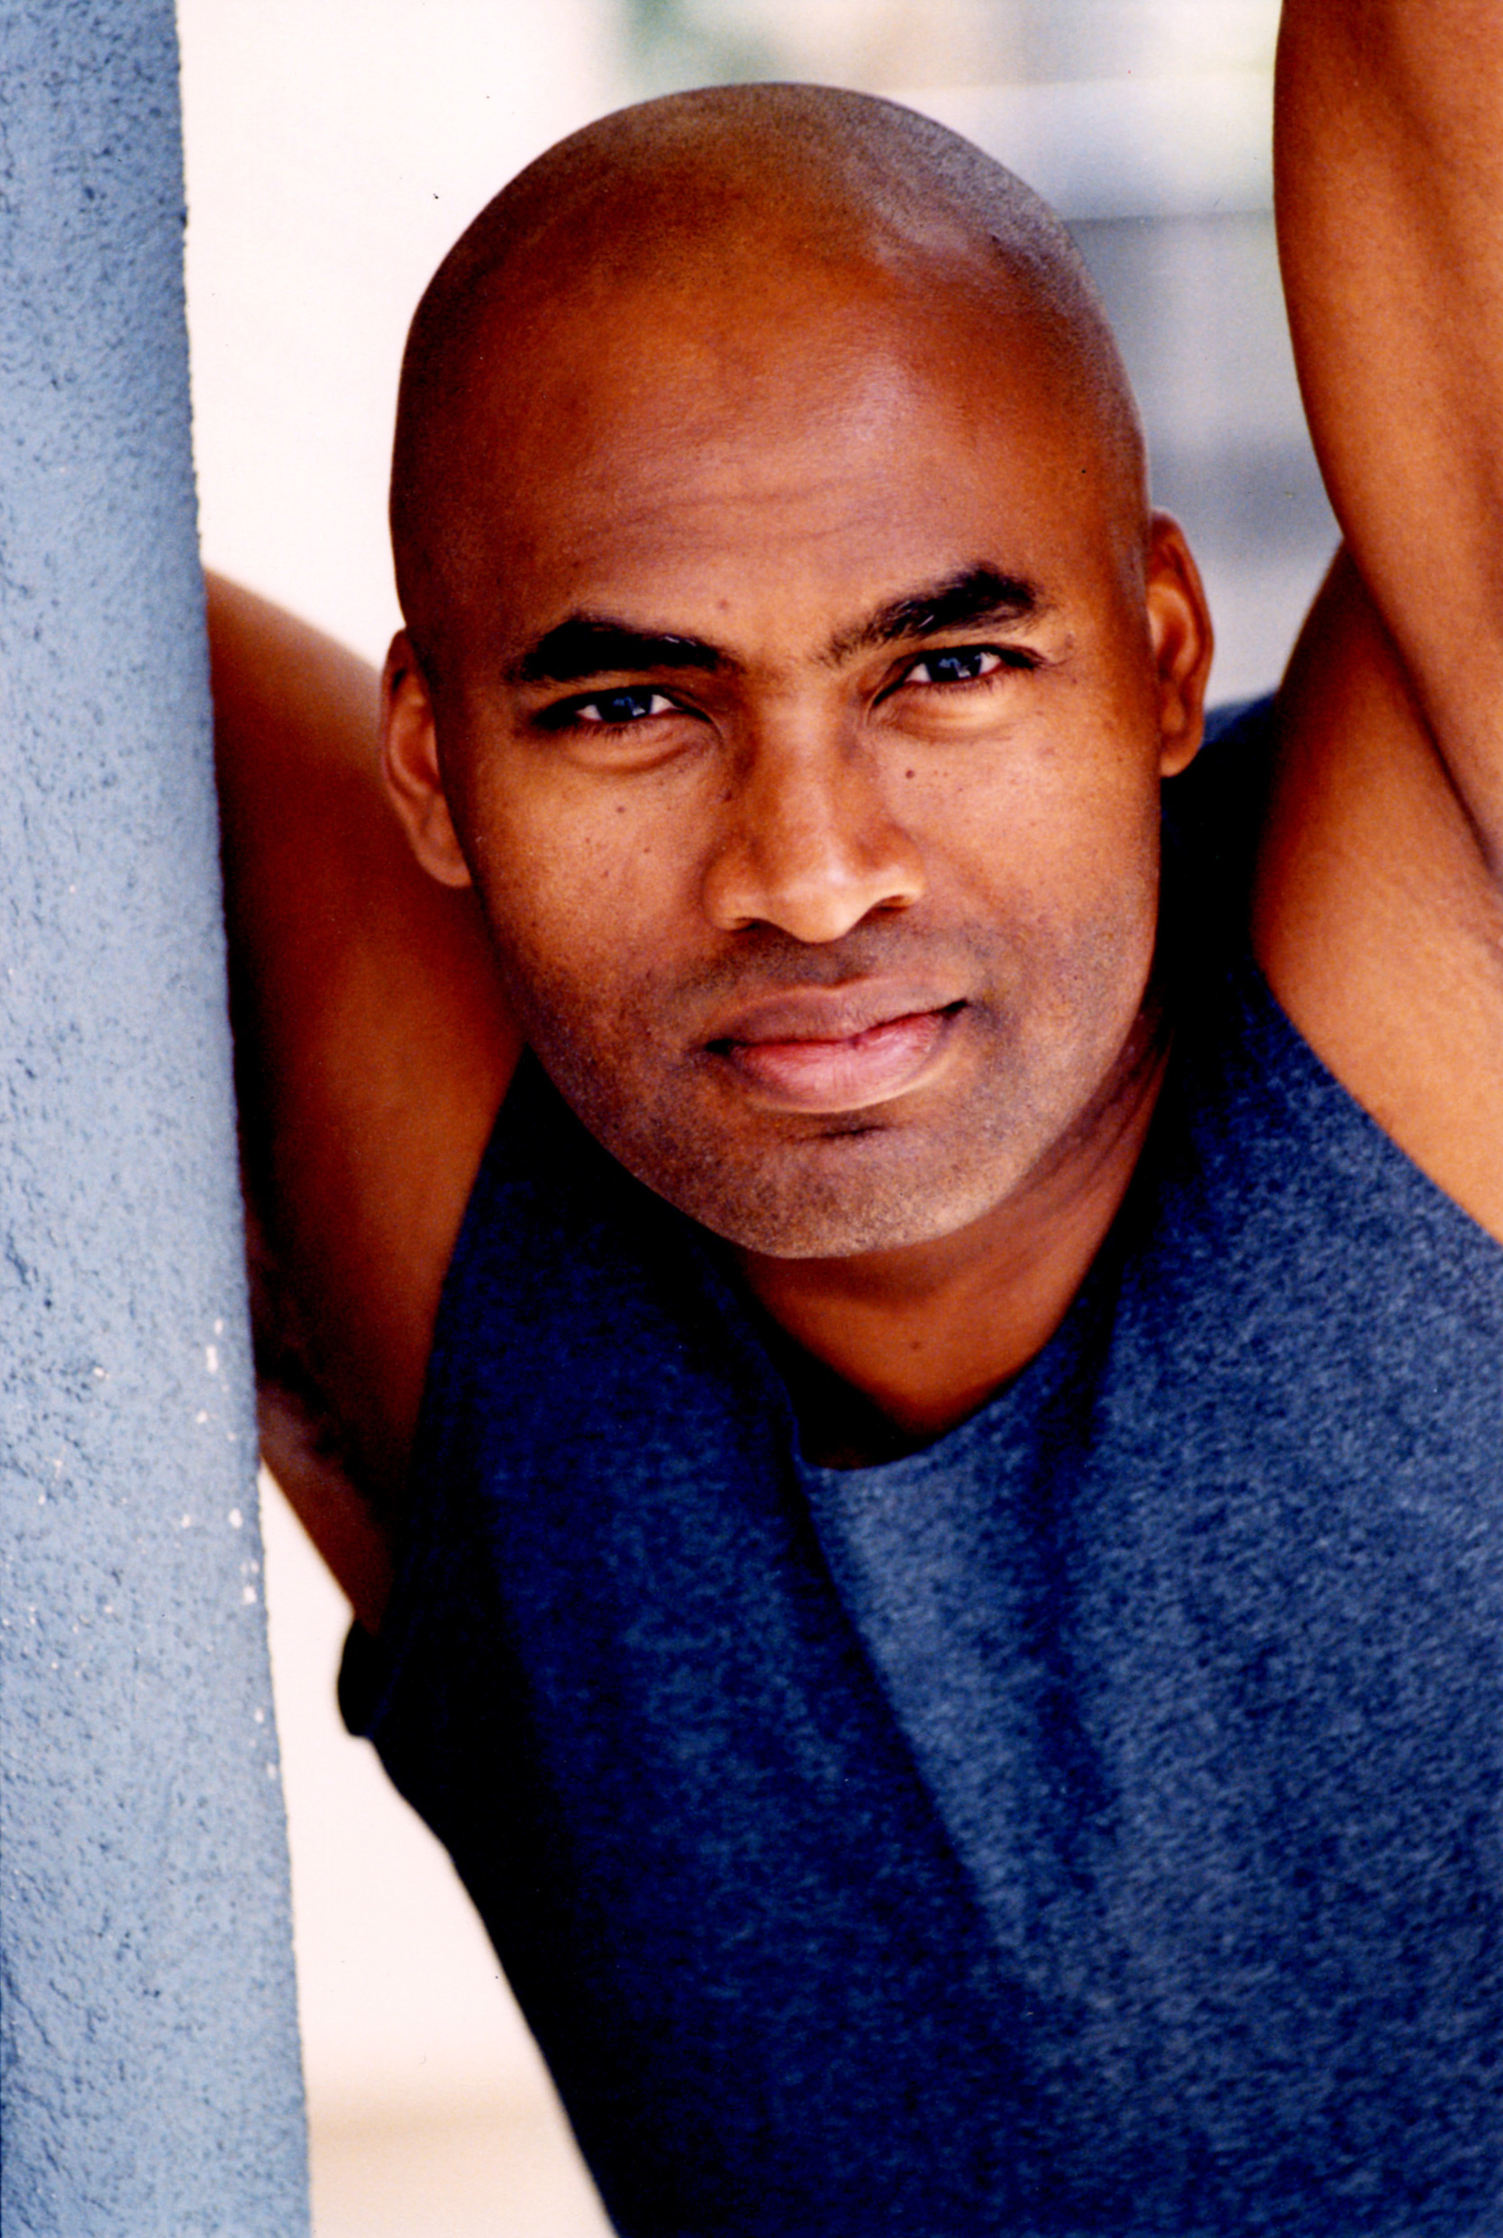

ANDRE KELLEY

Taken from a crashed rocket ship in a Kansas cornfield, Andre was adopted and raised in a small town not far from his play-brother Clark Kent....

Actually, he's the corn-fed, beef-eating, milk-drinking, hay-bailing, thicker-than-Snicker, country-ass farm boy that Instinct magazine calls, ‘refreshingly defiant.’ And, he's the only Black comic in the entire country who’s never, ever, ever appeared on B.E.T.

Multi-hyphenate, comic-writer-actor, Andre is stand-up’s best-known gay farm boy. He’s appeared on Comedy Central’s Premium Blend, VH1’s Best Week Ever, LOGO’s Wisecrack and Si TV’s Latino Laugh Festival and Breakfast, Lunch & Dinner.

A headlining act with Atlantis Cruises and a featured performer at legendary clubs the Laugh Factory, LA Improv and the Ice House, he's appeared at the Chicago Comedy Festival, Miami Light Project's Come Out Laughing and twice at Michigan’s Gay & Lesbian Comedy Fest. He's also opened shows for Bill Maher, Margaret Cho, Carrot Top, Sinbad, Mo’Nique and Bill Hicks.

Currently penning his comedy specials Cornfed, Chick Magnet and The New Black, he’s ardently riding what he calls the ‘Brokeback Effect.’ Having done more than 500 shows in 45 states, audiences nationwide are discovering his broad yet specific appeal.

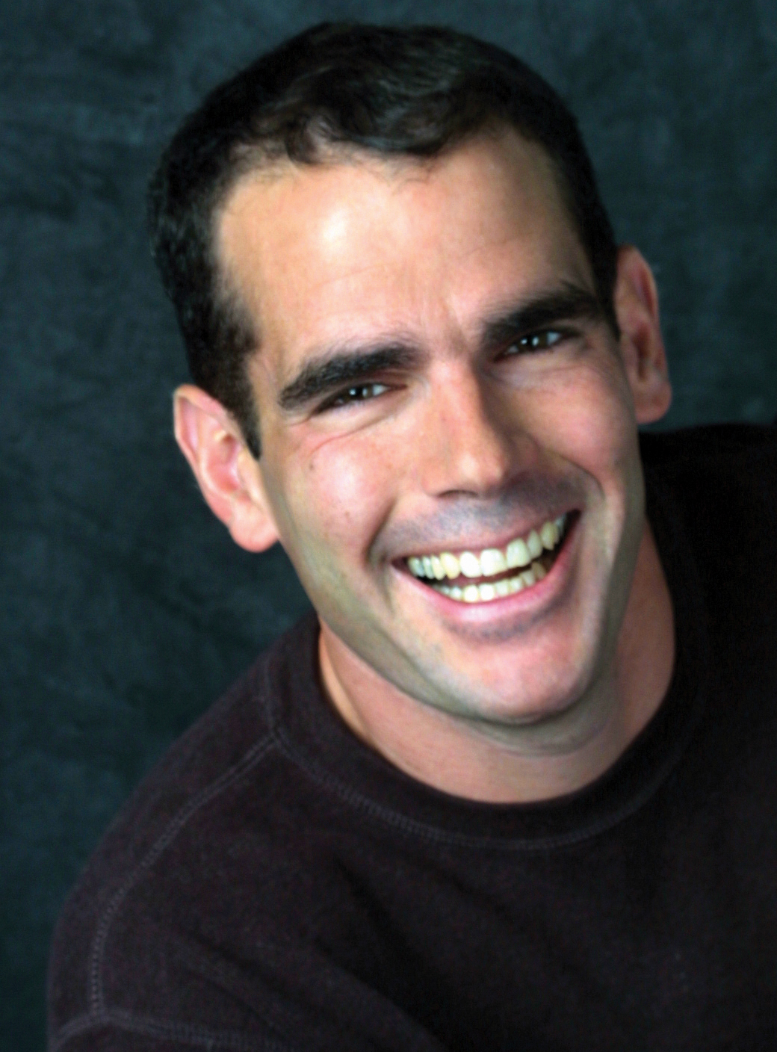

EDDIE SAFARTY

Comedian and writer Eddie Sarfaty has appeared on The Today Show, Nightline and on Comedy Central's Premium Blend. He is a regular at Caroline’s and Gotham Comedy Club in New York and has performed at Montreal’s Just for Laughs Comedy Festival, New York's Toyota Comedy Festival and at festivals in Columbus, Detroit, Miami, Phoenix and Washington, DC. Eddie has entertained on college campuses nationwide and at fundraisers for a variety of social and political organizations, including The National Gay & Lesbian Task Force, HRC and Lambda Legal. A favorite of crowds in Key West and Rehoboth, Eddie has also spent many summers in Provincetown, performing solo and as the newest member of the groundbreaking troupe Funny Gay Males. In addition he has been a featured performer for Atlantis Cruises, Aquafest Cruises, Romance Voyages and RSVP Vacations. Recently Eddie’s short story Second Guessing Grandma received critical acclaim when it appeared in the bestselling anthology When I Knew by Regan Books, a division of Harper Collins. Since 2003 he has been on the faculty of The Theatre Lab in Washington, DC, where he teaches workshops on comedy writing and performing. Eddie recently signed a book deal with Kensington Press and is also working on several projects as a writer/performer for Logo.

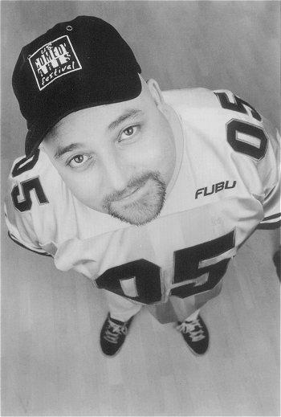

SCOTT KENNEDY

The Hollywood Reporter calls Scott, "…one of the most successful gay stand-up comics to ever tour the world." Scott co-founded the Gay Comedy Jam, which toured to sold-out crowds in more than 150 cities across the US and Canada.

A native Texan, Scott is a favorite on CMT Countdown on Country Music Television and had his own half-hour special on Comedy Central Presents. He’s appeared on Premium Blend, NBC's Last Comic Standing, CBS's The Late Late Show and ABC’s Good Morning America.

2007 marks the 18th year of standup comedy for Scott. He headlines at clubs and colleges across the country and is a favorite on XM radio. He continues to be in demand at Harrah's in Las Vegas, performing to sold-out crowds up to five times a year, and Comedy Central lists him as one of the top 100 comics of all time.

On the road up to 260 days a year, Scott has entertained the troops in Iraq and Afghanistan five times, and joined the 2006 X-Mas USO tour to South America. The troops love him and he proudly supports them throughout the year.

Scott has performed at the Montreal Comedy Festival, Just for Laughs and HBO’s Aspen Comedy Festival. His latest CD, released in April 2006, Scott Kennedy...Really!?!?!, has received rave reviews. Really!?!?! is Scott's third CD, following Gay from Las Vegas and The Gay Comedy Jam Live.

Scott started doing standup comedy in his hometown of Lubbock, Texas, eventually moving to Los Angeles, where he is a favorite at The Improv and the Comedy Store.

CAST and CREW…

Executive Producer & Director
Andrea Meyerson

Director of Photography
Sandra Chandler
Editor
Jen Bradwell

Associate Producer
Catherine Gray

Cast
Andre Kelley
Scott Kennedy
Alec Mapa
Eddie Sarfaty
Bob Smith
Bruce Vilanch
Special Appearance By
Honey Labrador
Interviewer
Laurie Schenden

Camera Operators
Nicola Marsh
Arthur Yee

Production Sound Mixer
Lori Dovi

Music by
tonehead & il moroso
A.K.A. Tony Humecke and Bill Morosi
Re-recording Mixer
Eric Happoldt

Graphics
Barbara Gottlieb
Yanko Sanchez
Rebecca Shotz
Technical Advisor
Mario DelBello
Makeup
Margo George
Production Assistants
Leena Chitnis
Micky Small
Tavia Smalley

Still Photography
Sherry Barnett
Public Relations
Jim Dobson / Indie PR
Stock Image Researchers
Hilarie Cuevas
Jacqueline Gares
Chris Hulen

Photographs and Images Courtesy of
American Friends Service Committee, San Francisco Regional Office, 1980
Corbis
Frontiers Publishing
Getty Images
Montreal Gazette Group Inc., a CanWest Partnership
New York Daily News, L.P. used with permission
ONE National Gay and Lesbian Archives
Photofest Inc.
Playbill, Inc.
Sun Media Corporation
Phyllis Christopher
Brad Fowler
Paul Kolnik
Joan Marcus
Brad Rader, ACT UP/LA
Scott Romer
Chuck Stallard
Rex Wockner
Special Thanks
Azul Restaurant
Bottom Line Magazine
Greater Palm Springs Pride, Inc.
The Horizon Hotel
Chantal Carrere
Barbara Carrington
Sam Day
Mona de Crinis
Jamie Kabler
Lynne Lowry
Glen Mayes
Toni Mazzeo
Tom Rauls
Tommi Rose
Ronni Sanlo
Jack Schloeder

Songs
“Dirty Criminal”
Performed by Jim Verraros
Written by Jim Verraros and Gabe Lopez

“Welcome to Hollywood”
Performed by Jim Verraros
Written by Jim Verraros and Gabe Lopez

Performance Location
Oasis Nightclub

Interview Location
Leisureland

Filmed on location in Palm Springs, California

ALL OUT FILMS
All Rights Reserved
© 2007

